9.69: a) Expressing angular frequencies in units of revolutions per minute may be accomodated by changing the units of the dynamic quantities; specifically,
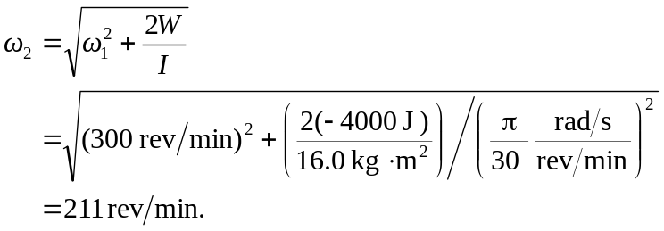

b) At the initial speed, the 4000 J will be recovered; if this is to be done is 5.00 s, the power must be 